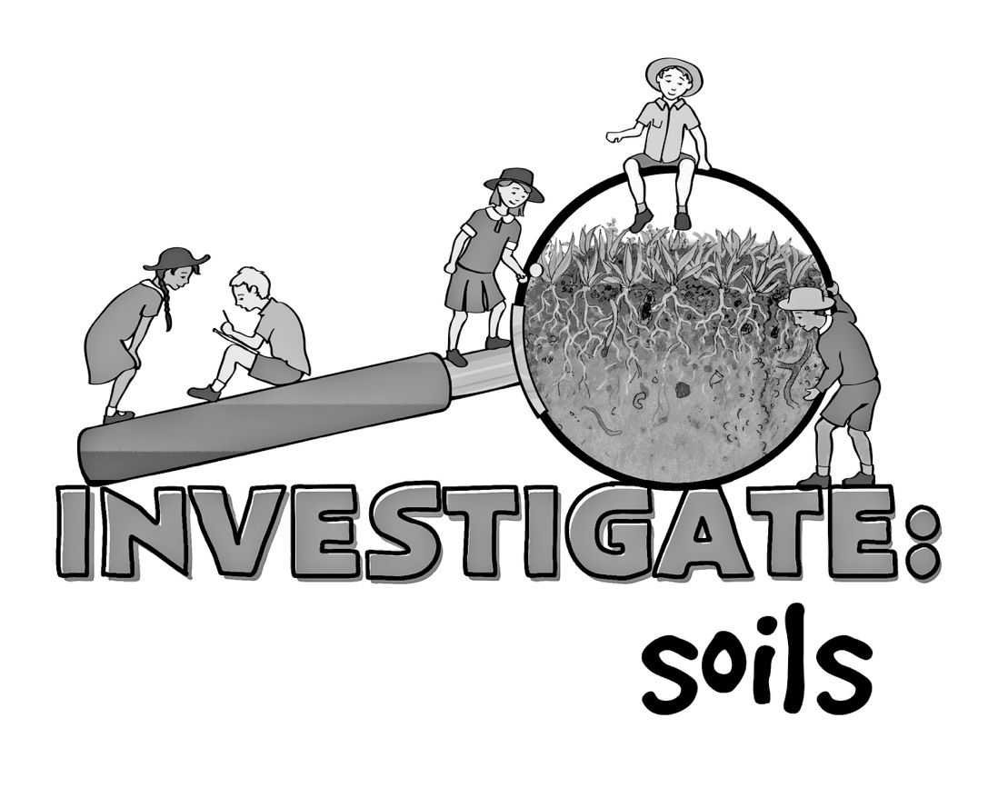
Name:

Stage 3 Science and Technology Competition
Student learning journal

Soils
What we know about soils:

What we would like to know about soils:

How we are going to find out:

What we learnt:

How soil is created
What surprised me about the video?

Does this change the way that I think about soil?

What does the Earth as an Apple activity demonstrate about soils?

Our soils
What are they like? Initial observations:

Do they appear to be good soils for growing food? Why or why not?

How are they different?

Which soil will be better for the plant? Why?

Soil trial
Draw the set up for the trial.
Make notes of the ways that you have ensured that this is a fair test of the soil quality.

Plant growth observations
Date | Soil 1 | Soil 2
Plant growth
Observations
Date | Soil 1 | Soil 2
Plant growth
Observations
Date | Soil 1 | Soil 2
Plant growth
Observations
Date | Soil 1 | Soil 2
Plant growth
Observations
Date | Soil 1 | Soil 2
Plant growth
Observations
Date | Soil 1 | Soil 2
Plant growth
Observations

Date | Soil 1 | Soil 2
Plant growth
Observations
Date | Soil 1 | Soil 2
Plant growth
Observations
Date | Soil 1 | Soil 2
Plant growth
Observations

Soil colour
Decide which colours on the chart below are closest to the colour of your soils and mark them on the chart.
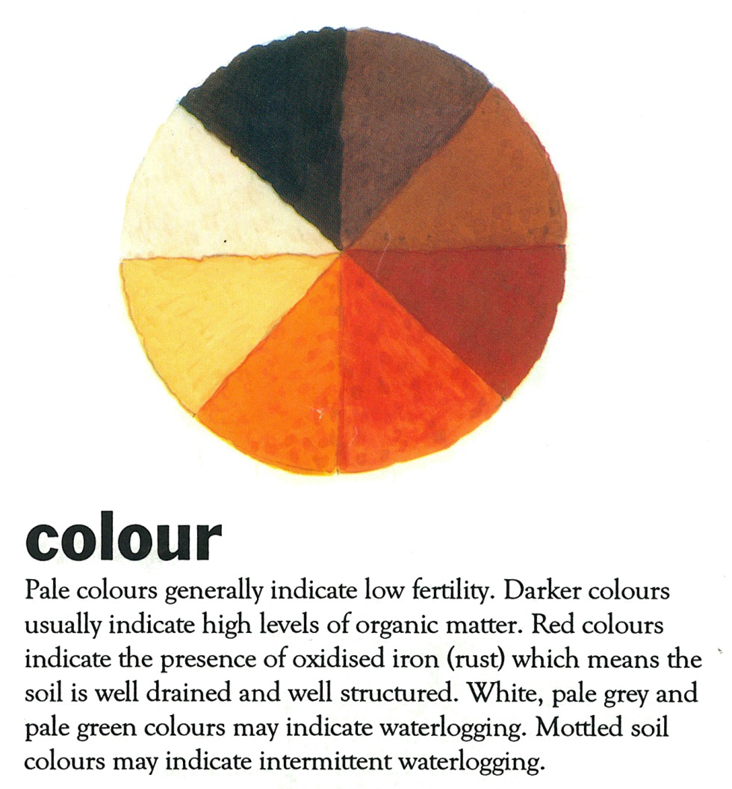

What does that mean for your soils?

Which one is a better soil for growing plants if judged by colour alone?

Soil texture
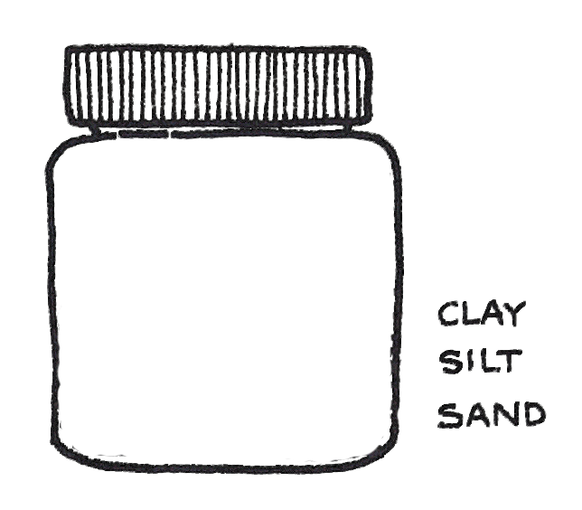
Draw the results of your jar test below and label with the percentages calculated during the activity.

Record the results of your ribbon test here:

What does that mean for your soils?

Which one is a better soil for growing plants if judged by texture alone?

Soil profile
(optional if you have access to the soil in situ)

Record the results of your observation of the soil profile here:

What does that mean for your soils?

Which one is a better soil for growing plants if judged by the soil profile alone?

Soil organisms
Which soil do you predict will have the most soil organism activity?

Record the results of the cotton strip test for soil organism activity here. Which soil had the most activity? Why do you think that is the case?

Soil chemistry

pH

Mark the pH of your soil samples on the card below.
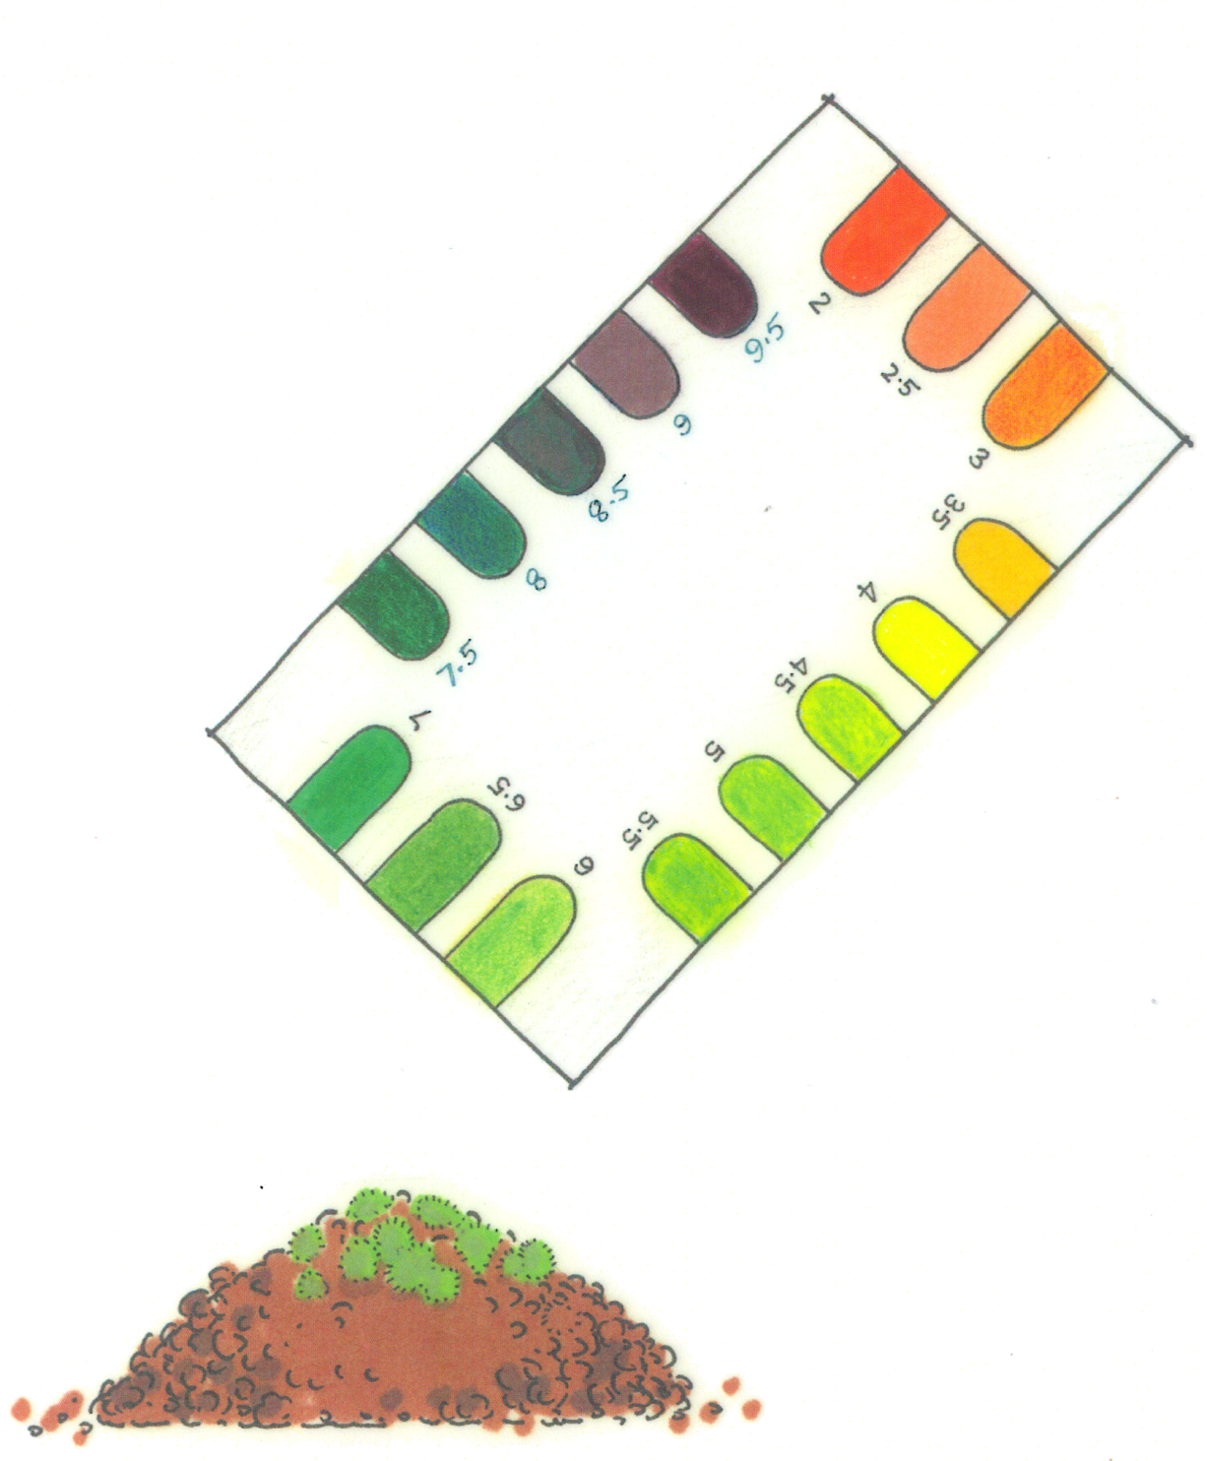
Which of your soil samples has a pH more suited to plant growth?

Soil stability
Draw the results of the soil stability assessment.

Are either of your soils dispersing or slaking soils?

What can you do to improve this soil?

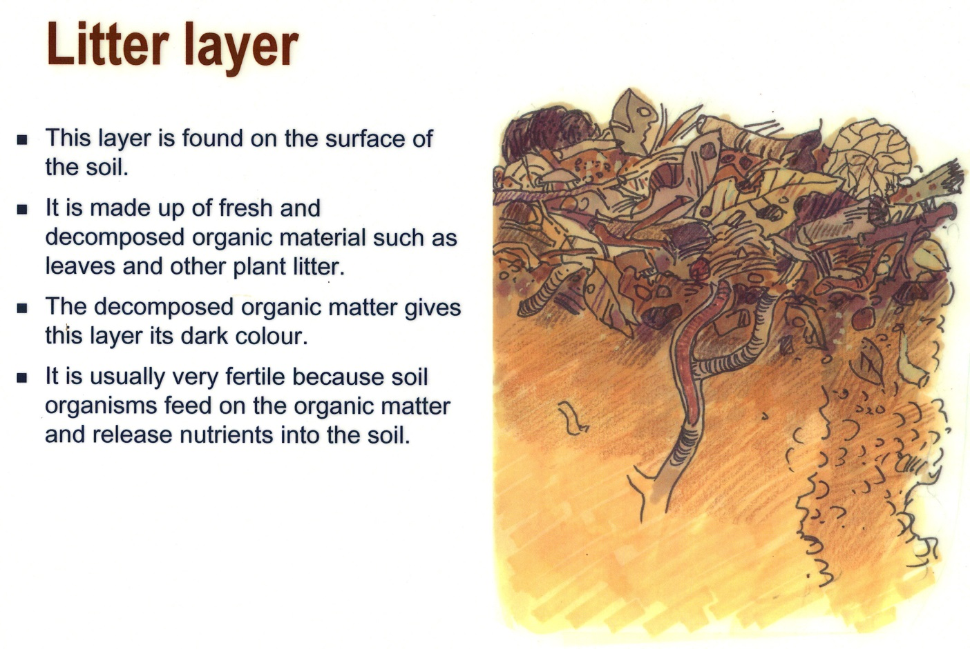

Organic matter
List some ways that you can improve the organic matter content in your garden soil:

Results
Which of the soils grew and stronger, healthier plants?

Draw the plants and how they look / compare at the end of the trial. Label the drawing, noting what tells you which one is healthier.
Why do you think that is? Look at the soil assessment results and see if you can decide which of the soils characteristics had the greatest effect on plant growth.

Would your soils be good for growing food and fibre on farms? Why or why not?

Report template
Title of Investigation:

Aim:
(What is the purpose of this investigation?)
The aim of the investigation is to

Hypothesis:
It is expected that

(Include a reason why you believe this will be the case and back it up with scientific understandings)

Variables:
List all the variables (factors that can alter the result of the experiment)
Name the independent variable (this is the factor that you changed):

Name the dependant variable: (this is the variable that you measured and observed)

List the variables that will be kept the same. These are the factors which you will control or keep the same

Controlled variable | How will you ensure it remains unchanged for all situations

Materials:
List the equipment you used

Method:
A step by step list describing how you set up and carried out the experiment. The method should have enough detail that anyone can use it to replicate or copy your experiment.

Diagram:
Include a diagram of how you set up the trial (make sure diagrams are labelled)

Results:
(Write, draw and make tables and graphs or take photos about your observations as you conduct the experiment)

Discussion:
Write a statement to summarise your findings and pose questions eg Why did this happen? Identify experimental errors. Suggest improvements to the procedure

Conclusion
(In sentences form: did the experiment prove what you expected from your hypothesis? Were the techniques very accurate? How could the procedure be improved?)

